Приложение А
Модульная сетка для desktop-версии

Рисунок П.А.1 - Шапка
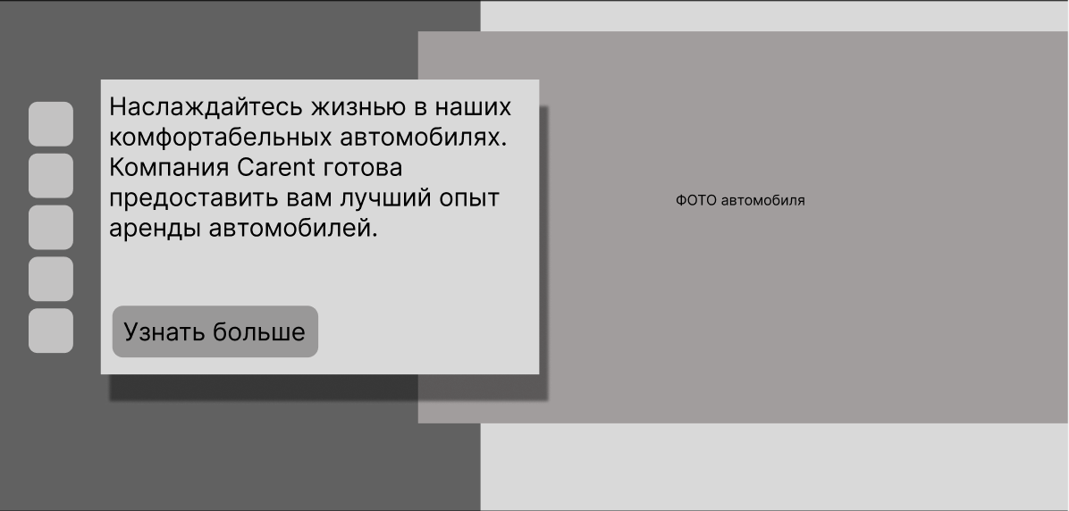
Рисунок П.А.2 - Главная

Рисунок П.А.3 – «О нас»
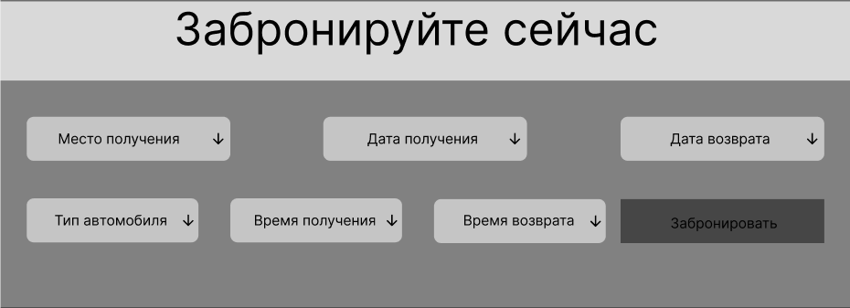
Рисунок П.А.4 – «Бронирование»
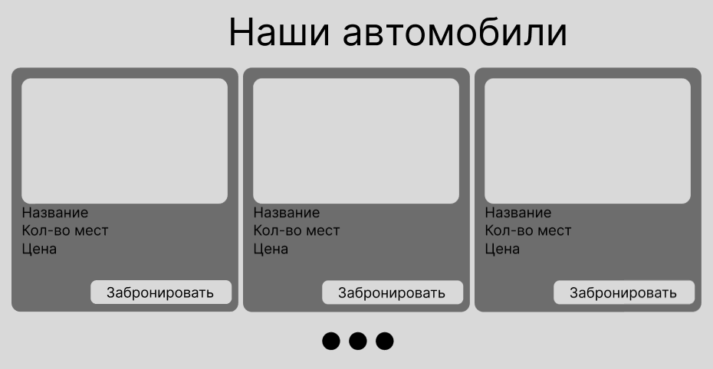
Рисунок П.А.5 – каталог автомобилей
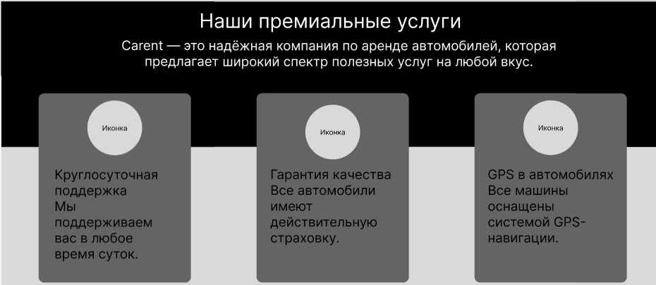
Рисунок П.А.6 – Премиальные услуги
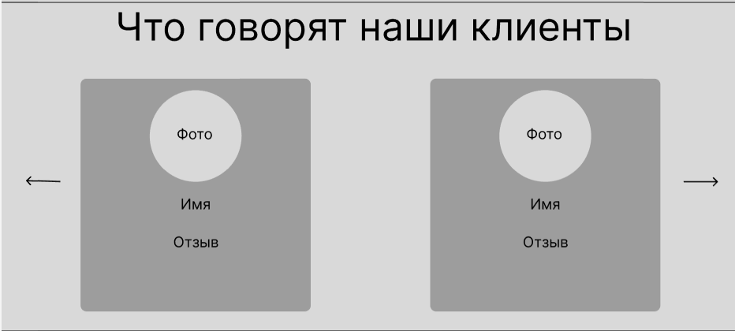
Рисунок П.А.7 - Отзывы

Рисунок П.А.8 – Статистика
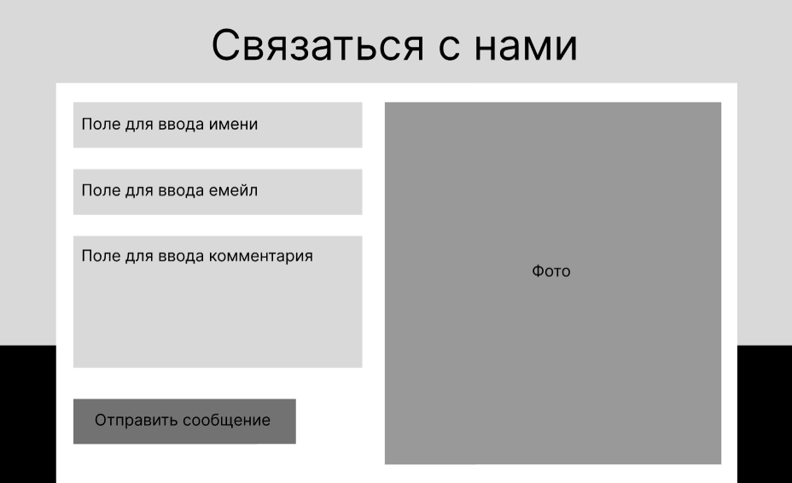
Рисунок П.А.9 – Форма обратной связи

Рисунок П.А.10 – Подвал

Приложение Б
Модульная сетка для планшетной версии

Рисунок П.Б.1 - Шапка
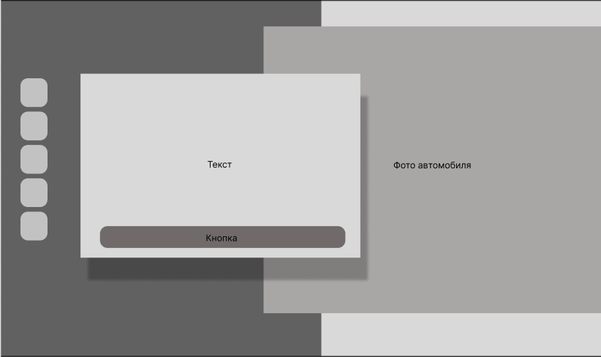
Рисунок П.Б.2 - Главная

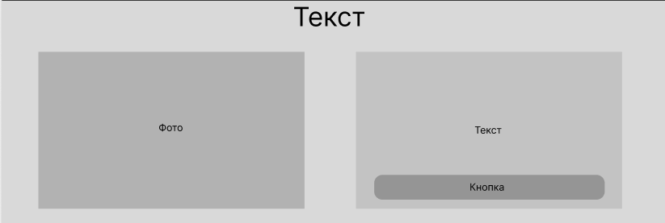
Рисунок П.Б.3 – «О нас»
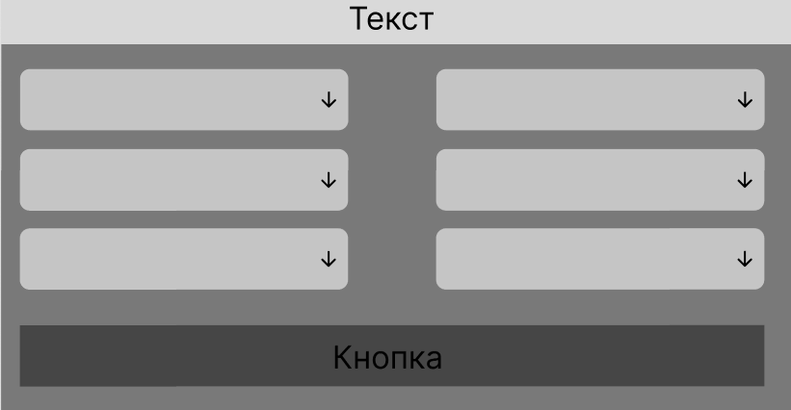
Рисунок П.Б.4 – Форма бронирования
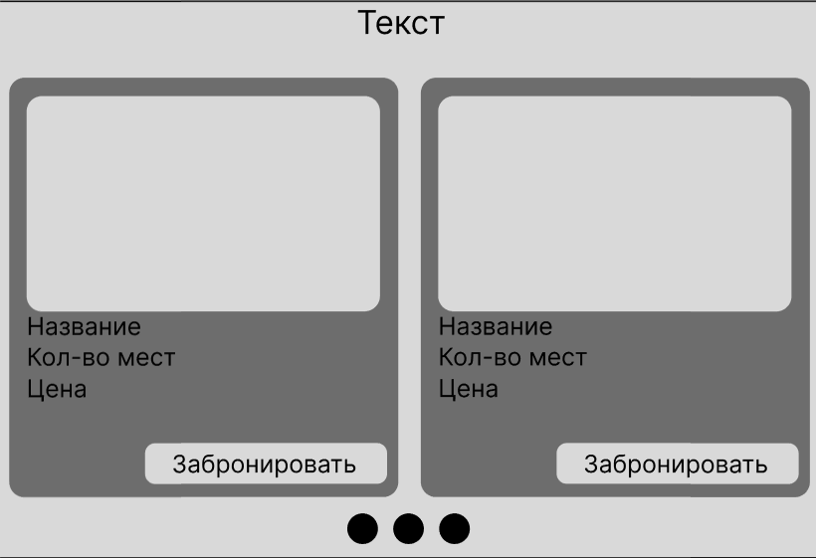
Рисунок П.Б.5 – Каталог автомобилей
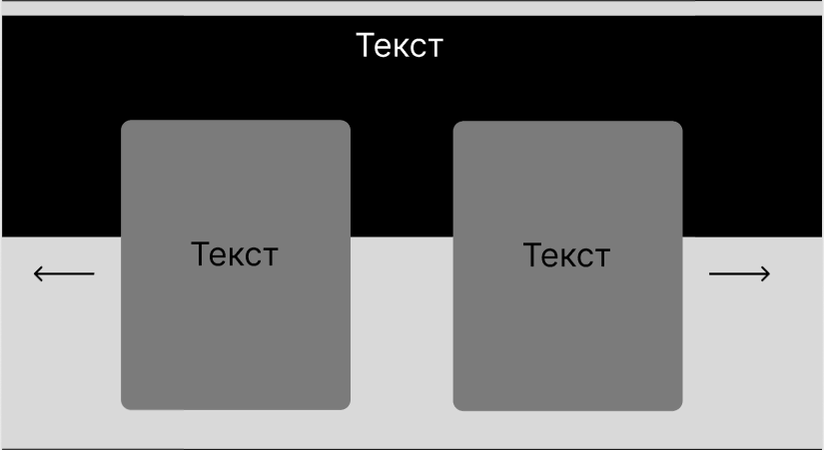
Рисунок П.Б.6 – Преимущества
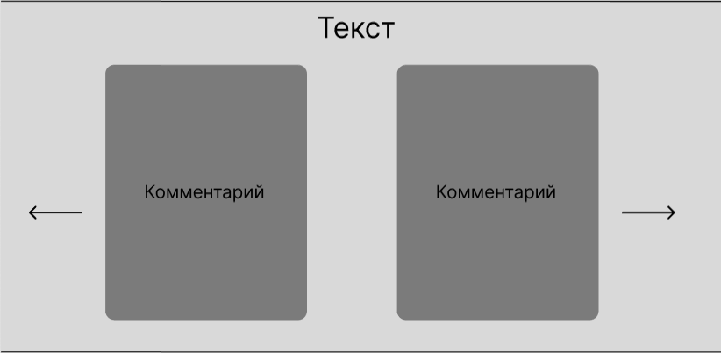
Рисунок П.Б.7 - Отзывы

Рисунок П.Б.8 - Статистика
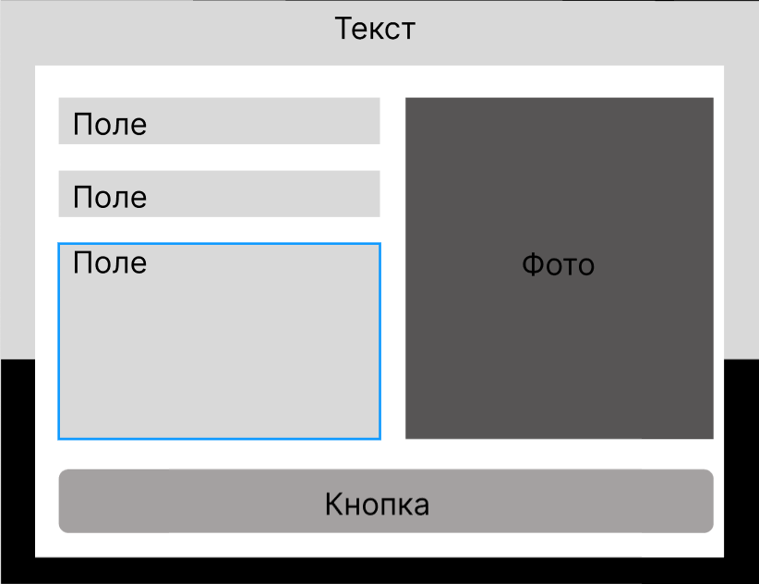
Рисунок П.Б.9 – Форма обратной связи

Рисунок П.Б.10 – Подвал

Приложение В
Модульная сетка для мобильной версии

  Рисунок П.В.1 - Шапка | 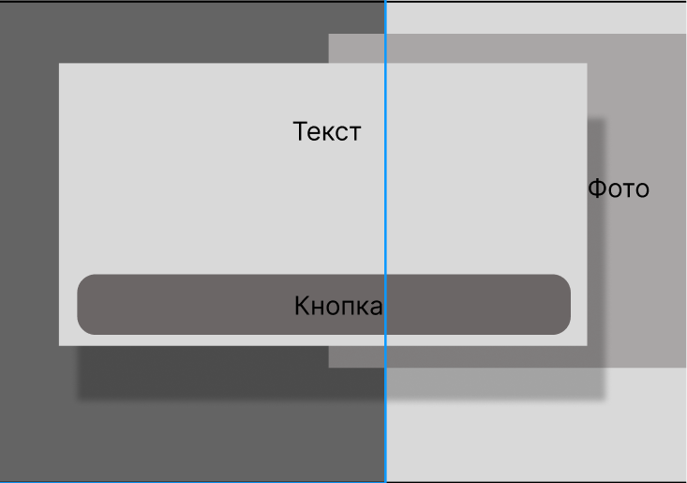 Рисунок П.В.2 - Главная
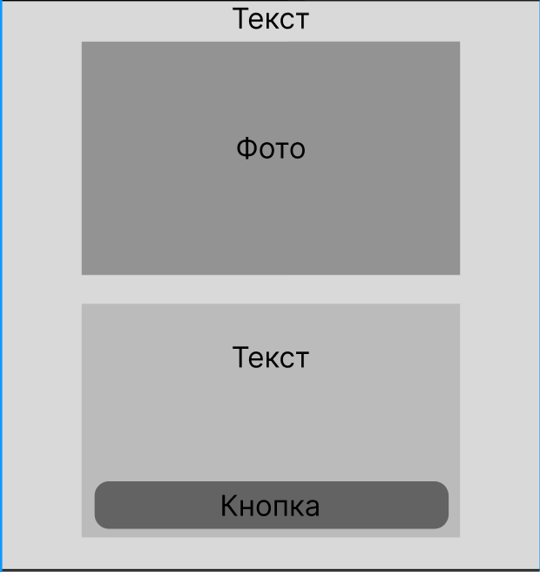  Рисунок П.В.3 – «О нас» | 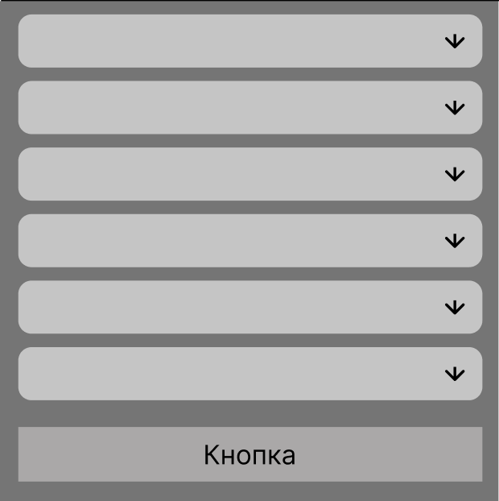  Рисунок П.В.4 – Форма бронирования
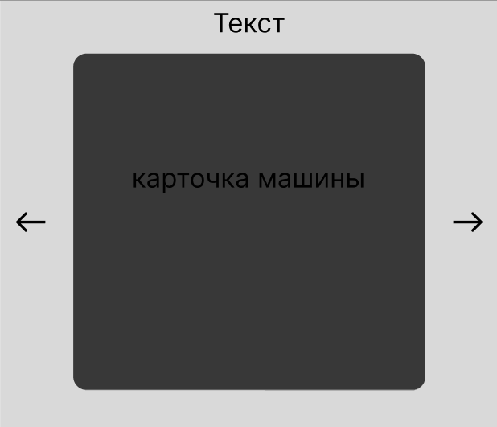  Рисунок П.В.5 – Каталог автомобилей | 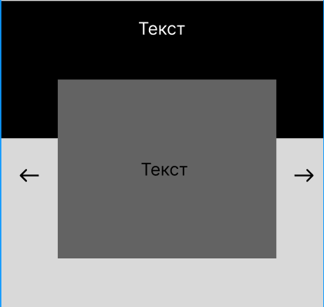  Рисунок П.В.6 – «О нас»
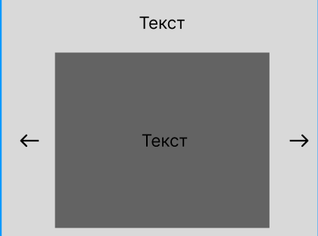  Рисунок П.В.7 – Комментарии | 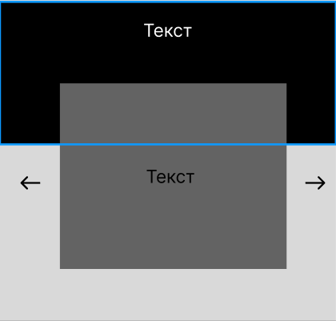  Рисунок П.В.8 – Преимущества
  Рисунок П.В.9 – Статистика | 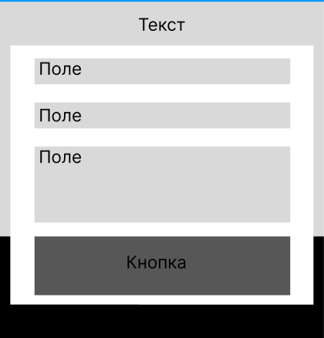  Рисунок П.В.10 – Форма обратной связи
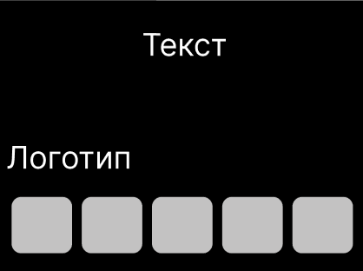
Рисунок П.В.11 – Подвал

Приложение Г
Листинг ручной верстки

<!DOCTYPE html>
<html lang="en">
<head>
<!-- 1. Сначала метатеги (важно для правильного отображения кодировки и мобильного масштаба) -->
<meta charset="UTF-8">
<meta name="viewport" content="width=device-width, initial-scale=1.0">

<title>Carent – Car Rental Service</title>

<!-- 2. Иконки Font Awesome -->
<link rel="stylesheet" href="https://cdnjs.cloudflare.com/ajax/libs/font-awesome/6.4.0/css/all.min.css">
<!-- 4. Ваши кастомные стили (в самом конце, чтобы перебивать Bootstrap при необходимости) -->
<link rel="stylesheet" href="style.css">
</head>
<body>

<!-- ========================================== -->
<!-- ХЕДЕР И ПЕРВЫЙ ЭКРАН (HEADER & HERO) -->
<!-- ========================================== -->
<header class="header">
<div class="header-left"></div>

<!-- Исправленный блок соцсетей на боковой панели по макету image_0a4164.jpg -->
<div class="social-bar">
<a href="#" class="hero-social-link" aria-label="Facebook">
<i class="fab fa-facebook-f"></i>
</a>
<a href="#" class="hero-social-link" aria-label="Instagram">
<i class="fab fa-instagram"></i>
</a>
<a href="#" class="hero-social-link" aria-label="Twitter">
<i class="fab fa-twitter"></i>
</a>
<a href="#" class="hero-social-link" aria-label="Telegram">
<i class="fab fa-telegram-plane"></i>
</a>
<a href="#" class="hero-social-link" aria-label="WhatsApp">
<i class="fab fa-whatsapp"></i>
</a>
</div>

<nav class="nav">
<div class="nav-left">
<div class="logo">Carent</div>
</div>

<button class="burger-menu" id="burgerToggle" aria-label="Открыть меню">
<span class="burger-bar"></span>
<span class="burger-bar"></span>
<span class="burger-bar"></span>
</button>

<div class="nav-right" id="navMenu">
<ul class="menu">
<li><a href="#">Home</a></li>
<li><a href="#">About</a></li>
<li><a href="#">Booking</a></li>
<li><a href="#">Cars</a></li>
<li><a href="#">Contacts</a></li>
</ul>
<a class="auth" href="#">Login | Sign up</a>
</div>
</nav>

<section class="hero">
<div class="hero-inner container">
<div class="hero-left">
<div class="hero-text">
<h1>Enjoy your life with our comfortable cars</h1>
<p>Carent is ready to serve the best experience in car rental.</p>
<button class="btn">Explore Now</button>
</div>
</div>
</div>
<div class="hero-image">
<img src="Main Picture.jpg" alt="Car">
</div>
</section>
</header>

<!-- ========================================== -->
<!-- СЕКЦИЯ "О НАС" (ABOUT) -->
<!-- ========================================== -->
<section class="about container">
<h2 class="section-title">About Us</h2>

<div class="about-content">
<div class="about-img-wrapper">
<img src="Rectangle 5.jpg" alt="About Us Car" class="about-img">
</div>

<div class="about-text">
<p>
We are a specialized team committed to providing reliable car rental services.
One of the advantages of renting a car from us is offering competitive and transparent prices.
By providing services such as comprehensive insurance ......
</p>
<a href="#" class="read-more">Read More</a>
</div>
</div>
</section>

<!-- ========================================== -->
<!-- СЕКЦИЯ БРОНИРОВАНИЯ (BOOKING) -->
<!-- ========================================== -->
<section class="booking">
<h2 class="section-title">Book Now</h2>

<div class="booking-bg">
<div class="container">
<form class="booking-grid">

<div class="input-field location-icon">
<select required>
<option value="" disabled selected hidden>Pickup Location</option>
<option value="airport">Main Airport</option>
<option value="city">City Center</option>
</select>
</div>

<div class="input-field date-icon">
<input type="text" placeholder="Pickup Date"
onfocus="(this.type='date')" onblur="if(!this.value)this.type='text'">
</div>

<div class="input-field date-icon">
<input type="text" placeholder="Return Date"
onfocus="(this.type='date')" onblur="if(!this.value)this.type='text'">
</div>

<div class="input-field car-icon">
<select required>
<option value="" disabled selected hidden>Car Type</option>
<option value="suv">SUV / Jeep</option>
<option value="sedan">Sedan</option>
</select>
</div>

<div class="input-field time-icon">
<input type="text" placeholder="Pickup Time"
onfocus="(this.type='time')" onblur="if(!this.value)this.type='text'">
</div>

<div class="input-field time-icon">
<input type="text" placeholder="Return Time"
onfocus="(this.type='time')" onblur="if(!this.value)this.type='text'">
</div>

<button type="submit" class="btn booking-btn">Book Now</button>

</form>
</div>
</div>
</section>

<!-- ========================================== -->
<!-- КАТАЛОГ МАШИН (FEATURED CARS) -->
<!-- ========================================== -->
<section class="featured container">
<h2 class="section-title">Our Featured Cars</h2>

<div class="cars-grid">
<div class="car-card">
<img src="Rectangle 6.jpg" alt="Jeep XD" class="car-img">
<h3>Jeep XD</h3>
<p class="specs">8 seats • Diesel • SUV</p>
<div class="car-footer">
<div class="price-block">
<span class="price-label">Daily rate from</span>
<span class="price-value">$200</span>
</div>
<a href="#" class="btn-book">Book Now</a>
</div>
</div>

<div class="car-card">
<img src="Rectangle 6-1.jpg" alt="Ferrari Enzo" class="car-img">
<h3>Ferrari Enzo</h3>
<p class="specs">2 seats • Electric • Sedan</p>
<div class="car-footer">
<div class="price-block">
<span class="price-label">Daily rate from</span>
<span class="price-value">$340</span>
</div>
<a href="#" class="btn-book">Book Now</a>
</div>
</div>

<div class="car-card">
<img src="Rectangle 6-2.jpg" alt="Fiat Cooper" class="car-img">
<h3>Fiat Cooper</h3>
<p class="specs">4 seats • Diesel • Mini coupe</p>
<div class="car-footer">
<div class="price-block">
<span class="price-label">Daily rate from</span>
<span class="price-value">$167</span>
</div>
<a href="#" class="btn-book">Book Now</a>
</div>
</div>
</div>
</section>

<!-- ========================================== -->
<!-- ПРЕИМУЩЕСТВА И СЕРВИСЫ (SERVICES) -->
<!-- СТИЛЬ СТРОГО ПО КАРТИНКЕ image_4b9b65.png -->
<!-- ========================================== -->
<section class="services">
<div class="services-top-bg">
<div class="container">
<h2 class="services-title">Our Premium Services</h2>
<p class="services-subtitle">Carent is a reputable car rental company that offers a wide range of useful services for every taste.</p>
</div>
</div>

<div class="services-cards-section">
<div class="container">
<div class="services-row">

<!-- Карточка 1 -->
<div class="service-card">
<div class="service-icon">
<img src="24_часа.png" alt="24 Hours Support">
</div>
<h3>24 Hours Support</h3>
<p>We support you all hours of the day,</p>
</div>

<!-- Карточка 2 -->
<div class="service-card">
<div class="service-icon">
<img src="Медалька.png" alt="Qualified Assurance">
</div>
<h3>Qualified Assurance</h3>
<p>All cars have a valid insurance.</p>
</div>

<!-- Карточка 3 -->
<div class="service-card">
<div class="service-icon">
<img src="Мишень.png" alt="GPS on Cars">
</div>
<h3>GPS on Cars</h3>
<p>All cars are equipped with GPS navigation system.</p>
</div>

</div>
</div>
</div>
</section>

<!-- ========================================== -->
<!-- ОТЗЫВЫ КЛИЕНТОВ (TESTIMONIALS) -->
<!-- ========================================== -->
<section class="testimonials container">
<h2 class="section-title">What Our Clients Say</h2>

<div class="testimonials-wrapper">

<button type="button" class="arrow-btn arrow-left">
<img src="arrow-left.png" alt="Previous">
</button>

<div class="testimonials-grid">
<!-- Отзыв 1 -->
<div class="testimonial">
<div class="testimonial-header">
<img src="Ellipse 62-2.png" alt="Kristin Watson" class="testimonial-avatar">
<div class="testimonial-meta">
<h3>Kristin Watson</h3>
<span class="testimonial-status">Verified Client</span>
</div>
</div>
<p class="testimonial-text">“Amazing service! The car was clean, comfortable, and the rental process was smooth. Highly recommend Carent for everyone!”</p>
</div>

<!-- Отзыв 2 -->
<div class="testimonial">
<div class="testimonial-header">
<img src="Ellipse 62-3.png" alt="Robert Fox" class="testimonial-avatar">
<div class="testimonial-meta">
<h3>Robert Fox</h3>
<span class="testimonial-status">Verified Client</span>
</div>
</div>
<p class="testimonial-text">“Great experience. Friendly staff and excellent vehicle selection. The prices are transparent, no hidden fees at all.”</p>
</div>
</div>

<button type="button" class="arrow-btn arrow-right">
<img src="arrow-right.png" alt="Next">
</button>

</div>
</section>

<!-- ========================================== -->
<!-- СТАТИСТИКА (STATS) — ПО КАРТИНКЕ image_4a3322.png -->
<!-- ========================================== -->
<section class="stats">
<div class="container">
<div class="stats-grid">

<div class="stat-item">
<span class="stat-number">450+</span>
<p class="stat-desc">Cars For Rent</p>
</div>

<div class="stat-item">
<span class="stat-number">800+</span>
<p class="stat-desc">Happy Clients</p>
</div>

<div class="stat-item">
<span class="stat-number">750+</span>
<p class="stat-desc">Rental Locations</p>
</div>

</div>
</div>
</section>

<!-- ========================================== -->
<!-- ФОРМА ОБРАТНОЙ СВЯЗИ (CONTACT) -->
<!-- ========================================== -->
<section class="contact-section">

<div class="contact-top-bg">
<div class="container">
<h2 class="contact-title">Contact Us</h2>
</div>
</div>

<div class="contact-bottom-bg">
<div class="container">

<div class="contact-card">

<form class="contact-form-wrapper">
<div class="form-group">
<input type="text" placeholder="Your Name*" required>
</div>
<div class="form-group">
<input type="email" placeholder="Your Email*" required>
</div>
<div class="form-group">
<textarea placeholder="Your Message" required></textarea>
</div>
<button type="submit" class="contact-submit-btn">Send A Message</button>
</form>

<div class="contact-image-wrapper">
<img src="Rectangle 8.jpg" alt="Car Renting">
</div>

</div>

<p class="contact-footer-phone">
Need help renting a car? Please call <span>+1-333-444-5555</span>
</p>

</div>
</div>

</section>

<!-- ========================================== -->
<!-- ПОДВАЛ САЙТА (FOOTER) — ПО МАКЕТУ image_0a4909.png -->
<!-- ========================================== -->
<footer class="main-footer">
<div class="container footer-container">

<div class="footer-logo">CARENT</div>

<div class="footer-socials">
<a href="#" class="social-link" aria-label="Facebook">
<i class="fab fa-facebook-f"></i>
</a>
<a href="#" class="social-link" aria-label="Instagram">
<i class="fab fa-instagram"></i>
</a>
<a href="#" class="social-link" aria-label="Twitter">
<i class="fab fa-twitter"></i>
</a>
<a href="#" class="social-link" aria-label="Telegram">
<i class="fab fa-telegram-plane"></i>
</a>
<a href="#" class="social-link" aria-label="WhatsApp">
<i class="fab fa-whatsapp"></i>
</a>
</div>

</div>
</footer>
<script>
const burgerToggle = document.getElementById('burgerToggle');
const navMenu = document.getElementById('navMenu');

// Открытие/закрытие меню по клику на бургер
burgerToggle.addEventListener('click', () => {
burgerToggle.classList.toggle('active');
navMenu.classList.toggle('active');
});

// Автоматическое закрытие меню при клике на любую ссылку внутри панели
document.querySelectorAll('.menu a, .auth').forEach(link => {
link.addEventListener('click', () => {
burgerToggle.classList.remove('active');
navMenu.classList.remove('active');
});
});
</script>

</body>
</html>

/* ==========================================================================
1. БАЗОВЫЕ И ОБЩИЕ СТИЛИ
========================================================================== */

* {
margin: 0;
padding: 0;
box-sizing: border-box;
font-family: Arial, sans-serif;
}

body {
background: #fff;
color: #222;
}

.container {
width: 90%;
max-width: 1200px;
margin: auto;
}

.btn {
padding: 12px 25px;
background: #ff7b00;
color: #000000;
border: none;
border-radius: 6px;
cursor: pointer;
font-size: 16px;
font-weight: bold;
text-decoration: none;
transition: 0.2s;
}

.btn:hover {
background: #e56f00;
}

.section-title {
text-align: center;
font-size: 34px;
font-weight: bold;
position: relative;
padding-bottom: 12px;
margin-bottom: 40px;
color: #222;
}

.section-title::after {
content: '';
position: absolute;
bottom: 0;
left: 50%;
transform: translateX(-50%);
width: 65px;
height: 3px;
background-color: #ff7b00;
}

/* ==========================================================================
2. ШАПКА И ПЕРВЫЙ ЭКРАН (HEADER & HERO) — ДЕСКТОПНЫЕ СТИЛИ
========================================================================== */

.header {
position: relative;
display: flex;
flex-direction: column;
}

.header-left {
position: absolute;
left: 0;
top: 0;
width: 50%;
height: 100%;
background: #000;
z-index: -1;
}

/* Боковая панель соцсетей (по макету image_0a4164.jpg) */
.social-bar {
position: absolute;
left: 25px;
top: 55%;
transform: translateY(-50%);
display: flex;
flex-direction: column;
gap: 12px;
z-index: 20;
}

/* Кнопки соцсетей (квадратные со скруглением) */
.hero-social-link {
display: flex;
align-items: center;
justify-content: center;
width: 34px;
height: 34px;
background-color: #ff8c00;
color: #14171c;
border-radius: 6px;
font-size: 1rem;
text-decoration: none;
transition: transform 0.2s ease, background-color 0.2s ease;
}

.hero-social-link:hover {
transform: scale(1.08);
background-color: #e07b00;
}

/* Навигационная панель */
.nav {
display: flex;
justify-content: space-between;
align-items: center;
padding: 25px 0;
position: relative;
}

.nav-left {
width: 50%;
}

.nav-right {
width: 50%;
display: flex;
justify-content: flex-end;
align-items: center;
gap: 25px;
transition: right 0.4s cubic-bezier(0.1, 1, 0.1, 1);
}

.logo {
font-size: 28px;
font-weight: bold;
color: #ff8c00;
transition: font-size 0.2s;
}

.menu {
display: flex;
gap: 25px;
list-style: none;
}

.menu a {
color: #222;
text-decoration: none;
font-size: 16px;
transition: color 0.2s;
}

.menu a:hover {
color: #ff8c00;
}

/* Кнопка авторизации */
.auth {
display: inline-block;
padding: 12px 25px;
background: #ff8c00;
color: #000;
border: none;
border-radius: 6px;
font-size: 16px;
font-weight: bold;
text-decoration: none;
cursor: pointer;
transition: 0.2s;
}

.auth:hover {
background: #e56f00;
}

/* Стили кнопки-бургера (по умолчанию скрыта) */
.burger-menu {
display: none;
flex-direction: column;
justify-content: space-between;
width: 30px;
height: 21px;
background: transparent;
border: none;
cursor: pointer;
padding: 0;
z-index: 100;
}

.burger-bar {
width: 100%;
height: 3px;
background-color: #ff8c00;
border-radius: 2px;
transition: all 0.3s ease-in-out;
}

/* Главный баннер (Hero) */
.hero {
position: relative;
height: 500px;
overflow: hidden;
}

.hero-inner {
position: relative;
z-index: 3;
height: 100%;
display: flex;
align-items: center;
}

.hero-left {
width: 50%;
}

/* ИСПРАВЛЕНО: Резиновый текст с clamp() под размеры экранов */
.hero-text {
color: #fff;
max-width: 420px;
padding-left: clamp(15px, 4vw, 40px);
width: 100%;
box-sizing: border-box;
}

.hero-text h1 {
font-size: clamp(26px, 4.5vw, 42px); /* Плавно сжимается от 42px до 26px */
line-height: 1.2;
margin-bottom: clamp(12px, 2.5vw, 20px);
}

.hero-text p {
font-size: clamp(15px, 2vw, 18px); /* Плавно сжимается от 18px до 15px */
line-height: 1.5;
margin-bottom: clamp(15px, 3vw, 25px);
}

.hero-image {
position: absolute;
top: 0;
right: 0;
width: 60vw;
height: 100%;
z-index: 1;
overflow: hidden;
background: #000;
}

.hero-image img {
width: 100%;
height: 100%;
object-fit: contain;
object-position: right center;
transform: translateX(-5%);
}

/* ==========================================================================
3. СЕКЦИЯ "О НАС" (ABOUT)
========================================================================== */

.about {
padding: 80px 0;
}

.about-content {
display: grid;
grid-template-columns: 1fr 1fr;
gap: 50px;
align-items: center;
}

.about-img-wrapper {
width: 100%;
}

.about-img {
width: 100%;
height: auto;
max-height: 400px;
object-fit: cover;
border-radius: 12px;
}

.about-text {
display: flex;
flex-direction: column;
gap: 25px;
text-align: left;
}

.about-text p {
font-size: 18px;
line-height: 1.7;
color: #555;
}

.about-text .read-more {
color: #ff7b00;
text-decoration: none;
font-weight: bold;
font-size: 18px;
align-self: flex-start;
transition: 0.2s;
}

.about-text .read-more:hover {
color: #e56f00;
}

/* ==========================================================================
4. СЕКЦИЯ БРОНИРОВАНИЯ (BOOKING)
========================================================================== */

.booking {
padding: 60px 0 20px 0;
}

.booking-bg {
background-color: #fde8cc;
padding: 50px 0;
width: 100%;
}

.booking-grid {
display: grid;
grid-template-columns: repeat(4, 1fr);
gap: 24px;
align-items: center;
}

.booking-grid .input-field {
width: 100%;
position: relative;
}

.booking-grid select,
.booking-grid input {
width: 100%;
height: 52px;
padding: 10px 20px 10px 45px;
border: none;
border-radius: 6px;
font-size: 15px;
color: #444;
background-color: #ffffff;
outline: none;
appearance: none;
-webkit-appearance: none;
}

.booking-grid input::-webkit-calendar-picker-indicator {
background: transparent;
bottom: 0;
color: transparent;
cursor: pointer;
height: auto;
left: 0;
position: absolute;
right: 0;
top: 0;
width: auto;
}

.booking-grid select:invalid {
color: #777;
}

.location-icon::before { content: '📍'; position: absolute; left: 15px; top: 16px; z-index: 5; }
.date-icon::before { content: '📅'; position: absolute; left: 15px; top: 16px; z-index: 5; }
.car-icon::before { content: '🚗'; position: absolute; left: 15px; top: 16px; z-index: 5; }
.time-icon::before { content: '🕒'; position: absolute; left: 15px; top: 16px; z-index: 5; }

.booking-grid select {
background-image: url("data:image/svg+xml;utf8,<svg xmlns='http://www.w3.org/2000/svg' width='14' height='14' viewBox='0 0 24 24' fill='none' stroke='%23444444' stroke-width='2' stroke-linecap='round' stroke-linejoin='round'><polyline points='6 9 12 15 18 9'></polyline></svg>");
background-repeat: no-repeat;
background-position: right 20px center;
}

.booking-grid .booking-btn {
width: 100%;
height: 52px;
font-size: 16px;
display: flex;
justify-content: center;
align-items: center;
}

/* ==========================================================================
5. КАТАЛОГ МАШИН (FEATURED CARS)
========================================================================== */

.featured {
padding: 60px 0;
}

.cars-grid {
display: grid;
grid-template-columns: repeat(3, 1fr);
gap: 30px;
padding: 20px 0 40px 0;
}

.car-card {
background: #fff;
border: 1px solid #e0e0e0;
border-radius: 6px;
overflow: hidden;
text-align: left;
padding: 20px;
display: flex;
flex-direction: column;
}

.car-img {
width: 100%;
height: 180px;
object-fit: cover;
border-radius: 4px;
margin-bottom: 20px;
}

.car-card h3 {
font-size: 22px;
font-weight: bold;
margin-bottom: 10px;
color: #111;
}

.car-card .specs {
font-size: 15px;
color: #666;
margin-bottom: 30px;
}

.car-footer {
display: flex;
justify-content: space-between;
align-items: center;
margin-top: auto;
}

.price-block {
display: flex;
flex-direction: column;
}

.price-label {
font-size: 13px;
color: #888;
}

.price-value {
font-size: 22px;
font-weight: bold;
color: #111;
}

.btn-book {
padding: 10px 18px;
background: #ff7b00;
color: #000000;
font-weight: bold;
font-size: 14px;
text-decoration: none;
border-radius: 4px;
transition: background 0.2s;
}

.btn-book:hover {
background: #e56f00;
}

/* ==========================================================================
6. ПРЕИМУЩЕСТВА И СЕРВИСЫ (SERVICES)
========================================================================== */

.services {
position: relative;
width: 100%;
background-color: #ffffff;
}

.services-top-bg {
background-color: #0f1012;
color: #ffffff;
text-align: center;
padding: 60px 20px 160px 20px;
}

.services-title {
font-size: 2.2rem;
font-weight: 600;
margin-bottom: 15px;
letter-spacing: 0.5px;
}

.services-title::after {
content: '';
display: block;
width: 65px;
height: 3px;
background-color: #ff8c00;
margin: 12px auto 0 auto;
}

.services-subtitle {
color: #9a9da2;
max-width: 550px;
margin: 20px auto 0 auto;
font-size: 1.05rem;
line-height: 1.6;
}

.services-cards-section {
max-width: 1200px;
margin: 0 auto;
padding: 0 20px 80px 20px;
}

.services-row {
display: grid;
grid-template-columns: repeat(3, 1fr);
gap: 30px;
margin-top: -100px;
position: relative;
z-index: 5;
}

.service-card {
background: #ffffff;
border-radius: 6px;
padding: 50px 35px;
text-align: center;
box-shadow: 0 15px 40px rgba(0, 0, 0, 0.06);
transition: transform 0.3s ease, box-shadow 0.3s ease;
}

.service-card:hover {
transform: translateY(-5px);
box-shadow: 0 20px 45px rgba(0, 0, 0, 0.1);
}

.service-icon {
width: 60px;
height: 60px;
margin: 0 auto 25px auto;
display: flex;
align-items: center;
justify-content: center;
}

.service-icon img {
width: 100%;
height: 100%;
object-fit: contain;
}

.service-card h3 {
font-size: 1.35rem;
color: #111111;
margin-bottom: 15px;
font-weight: 600;
}

.service-card p {
font-size: 0.95rem;
color: #777777;
line-height: 1.6;
padding: 0 10px;
}

/* ==========================================================================
7. ОТЗЫВЫ КЛИЕНТОВ (TESTIMONIALS)
========================================================================== */

.testimonials {
padding: 80px 0;
}

.testimonials-wrapper {
position: relative;
width: 100%;
padding: 0 70px;
}

.testimonials-grid {
display: grid;
grid-template-columns: repeat(2, 1fr);
gap: 30px;
width: 100%;
}

.testimonial {
padding: 40px 30px 30px 30px;
background: #ffffff;
border-radius: 12px;
border: 1px solid #eef0f2;
box-shadow: 0 4px 20px rgba(0, 0, 0, 0.02);
text-align: center;
}

.testimonial-header {
display: flex;
flex-direction: column;
align-items: center;
gap: 15px;
margin-bottom: 20px;
}

.testimonial-avatar {
width: 75px;
height: 75px;
border-radius: 50%;
object-fit: cover;
background-color: #eee;
}

.testimonial-meta {
text-align: center;
}

.testimonial-meta h3 {
font-size: 18px;
font-weight: bold;
color: #111;
margin-bottom: 4px;
}

.testimonial-status {
font-size: 13px;
color: #ff7b00;
}

.testimonial-text {
font-size: 15px;
color: #555;
line-height: 1.6;
font-style: italic;
}

.arrow-btn {
position: absolute;
top: 50%;
transform: translateY(-50%);
width: 45px;
height: 45px;
border-radius: 50%;
border: 1px solid #ddd;
background: #ffffff;
display: flex;
justify-content: center;
align-items: center;
cursor: pointer;
z-index: 10;
transition: all 0.2s ease;
}

.arrow-left { left: 0; }
.arrow-right { right: 0; }

.arrow-btn img {
width: 16px;
height: 16px;
object-fit: contain;
}

.arrow-btn:hover {
background: #ff7b00;
border-color: #ff7b00;
}

.arrow-btn:hover img {
filter: brightness(0) invert(1);
}

/* ==========================================================================
8. СТАТИСТИКА (STATS)
========================================================================== */

.stats {
background-color: #fbead2;
padding: 50px 0;
width: 100%;
border: none;
margin: 40px 0;
}

.stats-grid {
display: grid;
grid-template-columns: repeat(3, 1fr);
text-align: center;
align-items: center;
}

.stat-item {
display: flex;
flex-direction: column;
gap: 8px;
}

.stat-number {
font-size: 2.8rem;
font-weight: 500;
color: #111111;
line-height: 1;
letter-spacing: 0.5px;
}

.stat-desc {
font-size: 1.1rem;
color: #555555;
font-weight: 400;
}

/* ==========================================================================
9. ФОРМА ОБРАТНОЙ СВЯЗИ (CONTACT)
========================================================================== */

.contact-section {
position: relative;
width: 100%;
background-color: #0f1012;
}

.contact-top-bg {
background-color: #ffffff;
text-align: center;
padding: 60px 20px 120px 20px;
}

.contact-title {
font-size: 2.2rem;
font-weight: 600;
color: #111111;
display: inline-block;
}

.contact-title::after {
content: '';
display: block;
width: 100%;
height: 3px;
background-color: #ff8c00;
margin-top: 10px;
}

.contact-bottom-bg {
background-color: #0f1012;
padding-bottom: 60px;
}

.contact-card {
background: #ffffff;
border-radius: 4px;
max-width: 950px;
margin: -80px auto 0 auto;
padding: 40px;
box-shadow: 0 15px 40px rgba(0, 0, 0, 0.15);
position: relative;
z-index: 5;
display: table;
width: 100%;
}

.contact-form-wrapper {
display: table-cell;
width: 50%;
vertical-align: top;
padding-right: 30px;
}

.form-group {
margin-bottom: 20px;
}

.contact-form-wrapper input,
.contact-form-wrapper textarea {
width: 100%;
padding: 14px 18px;
border: 1px solid #e0e0e0;
background-color: #fafafa;
border-radius: 4px;
font-size: 0.95rem;
outline: none;
color: #333333;
}

.contact-form-wrapper textarea {
height: 120px;
resize: none;
}

.contact-submit-btn {
background-color: #ff8c00;
color: #000000;
padding: 14px 35px;
font-size: 1rem;
font-weight: 600;
border: none;
border-radius: 4px;
cursor: pointer;
transition: background-color 0.2s ease;
}

.contact-submit-btn:hover {
background-color: #e07b00;
}

.contact-image-wrapper {
display: table-cell;
width: 50%;
vertical-align: middle;
}

.contact-image-wrapper img {
width: 100%;
height: auto;
border-radius: 4px;
display: block;
object-fit: cover;
}

.contact-footer-phone {
text-align: center;
color: #9a9da2;
font-size: 1.05rem;
margin-top: 40px;
font-weight: 400;
}

.contact-footer-phone span {
color: #ff8c00;
font-weight: 600;
}

/* ==========================================================================
10. ПОДВАЛ САЙТА (FOOTER)
========================================================================== */

.main-footer {
background-color: #0f1012;
padding: 30px 0;
width: 100%;
border-top: 1px solid #222224;
}

.footer-container {
display: flex;
justify-content: space-between;
align-items: center;
}

.footer-logo {
color: #ff8c00;
font-size: 1.5rem;
font-weight: 800;
letter-spacing: 1px;
text-transform: uppercase;
}

.footer-socials {
display: flex;
gap: 15px;
}

.social-link {
display: flex;
align-items: center;
justify-content: center;
width: 38px;
height: 38px;
background-color: #ff8c00;
color: #0f1012;
border-radius: 6px;
font-size: 1.1rem;
text-decoration: none;
transition: transform 0.2s ease, background-color 0.2s ease;
}

.social-link:hover {
transform: translateY(-3px);
background-color: #e07b00;
}

/* ==========================================================================
11. АДАПТИВНОСТЬ И УСЛОВИЯ ДЛЯ ЭКРАНОВ (ОБЩИЙ МЕДИА-БЛОК)
========================================================================== */

/* --- А: ПЛАНШЕТНЫЙ РЕЖИМ И МОБИЛЬНЫЕ (ЭКРАНЫ МЕНЬШЕ 992px) --- */
@media screen and (max-width: 992px) {

/* 1. Навигация переходит в бургер */
.burger-menu {
display: flex;
}

.social-bar {
display: none; /* Скрываем боковую панель соцсетей */
}

.nav-right {
position: fixed;
right: -100%;
top: 0;
width: 280px;
height: 100vh;
background-color: #14171c;
box-shadow: -5px 0 15px rgba(0, 0, 0, 0.4);
flex-direction: column;
justify-content: flex-start;
align-items: flex-start;
gap: 35px;
padding: 100px 40px 40px 40px;
z-index: 99;
}

.nav-right.active {
right: 0;
}

.menu {
flex-direction: column;
gap: 25px;
width: 100%;
}

.menu a {
color: #ffffff;
font-size: 18px;
font-weight: 500;
display: block;
width: 100%;
}

.auth {
width: 100%;
text-align: center;
box-sizing: border-box;
}

/* Анимация бургера */
.burger-menu.active .burger-bar:nth-child(1) { transform: translateY(9px) rotate(45deg); }
.burger-menu.active .burger-bar:nth-child(2) { opacity: 0; }
.burger-menu.active .burger-bar:nth-child(3) { transform: translateY(-9px) rotate(-45deg); }

/* 2. Секция Сервисы перестраивается в 1 ряд */
.services-row {
grid-template-columns: 1fr;
margin-top: -50px;
gap: 20px;
}
.services-top-bg {
padding-bottom: 100px;
}
}

/* --- Б: ПЛАНШЕТНЫЕ СТИЛИ (КОНТРОЛЬНАЯ ТОЧКА 950px) --- */
@media screen and (max-width: 950px) {
.hero {
height: auto;
padding: 60px 0;
}
.hero-inner {
flex-direction: column;
align-items: flex-start;
gap: 40px;
}
.hero-left {
width: 100%;
}
}

/* --- В: СТАНДАРТНЫЕ МОБИЛЬНЫЕ (ЭКРАНЫ МЕНЬШЕ 768px) --- */
@media screen and (max-width: 768px) {
.about-content {
grid-template-columns: 1fr;
gap: 30px;
}
.booking-grid, .cars-grid, .testimonials-grid {
grid-template-columns: 1fr;
}
.stats-grid {
grid-template-columns: 1fr;
gap: 35px;
}
.contact-card {
display: block;
margin-top: -50px;
padding: 20px;
}
.contact-form-wrapper,
.contact-image-wrapper {
display: block;
width: 100%;
padding-right: 0;
}
.contact-image-wrapper {
margin-top: 30px;
}
.contact-top-bg {
padding-bottom: 90px;
}
}

/* --- Г: МАЛЕНЬКИЕ ТЕЛЕФОНЫ (КОНТРОЛЬНАЯ ТОЧКА 350px) --- */
@media screen and (max-width: 350px) {
.logo {
font-size: 22px;
}
.hero-text {
padding-left: 10px;
}
.hero-text .auth {
padding: 10px 20px;
font-size: 14px;
width: 100%;
text-align: center;
}
}

/* --- Д: МИКРО-ТЕЛЕФОНЫ (МЕНЬШЕ 576px ПОДВАЛ) --- */
@media screen and (max-width: 576px) {
.footer-container {
flex-direction: column;
gap: 20px;
text-align: center;
}
}

Приложение Д
Листинг верстки bootstrap5

<!DOCTYPE html>
<html lang="ru">
<head>
<meta charset="UTF-8">
<meta name="viewport" content="width=device-width, initial-scale=1.0">
<title>Carent – Car Rental Service | Bootstrap + Widgets</title>

<!-- Bootstrap 5 CSS + Icons + Font Awesome -->
<link href="https://cdn.jsdelivr.net/npm/bootstrap@5.3.0-alpha1/dist/css/bootstrap.min.css" rel="stylesheet">
<link rel="stylesheet" href="https://cdnjs.cloudflare.com/ajax/libs/font-awesome/6.4.0/css/all.min.css">

<!-- Подключаем внешний кастомный CSS -->
<link rel="stylesheet" href="style.css">
</head>
<body>

<!-- ======================= TOAST-УВЕДОМЛЕНИЕ (ВИДЖЕТ) ======================= -->
<div class="toast-container position-fixed bottom-0 end-0 p-3" style="z-index: 1100;">
<div id="welcomeToast" class="toast" role="alert" aria-live="assertive" aria-atomic="true" data-bs-autohide="true" data-bs-delay="5000">
<div class="toast-header bg-warning text-dark">
<i class="fas fa-car me-2"></i>
<strong class="me-auto">Carent</strong>
<small>Только что</small>
<button type="button" class="btn-close" data-bs-dismiss="toast" aria-label="Закрыть"></button>
</div>
<div class="toast-body">
🚗 Добро пожаловать в Carent! Арендуйте авто мечты по лучшим ценам.
</div>
</div>
</div>

<!-- ======================= НАВИГАЦИЯ ======================= -->
<nav class="navbar navbar-expand-lg bg-white py-3 border-bottom">
<div class="container">
<a class="navbar-brand fw-bold fs-2 logo-orange" href="#">Carent</a>
<button class="navbar-toggler" type="button" data-bs-toggle="collapse" data-bs-target="#mainNavbar">
<span class="navbar-toggler-icon"></span>
</button>
<div class="collapse navbar-collapse" id="mainNavbar">
<ul class="navbar-nav ms-auto mb-2 mb-lg-0 align-items-lg-center gap-lg-3">
<li class="nav-item"><a class="nav-link fw-semibold" href="#">Home</a></li>
<li class="nav-item"><a class="nav-link fw-semibold" href="#">About</a></li>
<li class="nav-item"><a class="nav-link fw-semibold" href="#">Booking</a></li>
<li class="nav-item dropdown">
<a class="nav-link dropdown-toggle fw-semibold" href="#" data-bs-toggle="dropdown">Cars</a>
<ul class="dropdown-menu">
<li><a class="dropdown-item" href="#">SUVs</a></li>
<li><a class="dropdown-item" href="#">Sedans</a></li>
<li><a class="dropdown-item" href="#">Electric</a></li>
<li><hr class="dropdown-divider"></li>
<li><a class="dropdown-item" href="#">All vehicles</a></li>
</ul>
</li>
<li class="nav-item"><a class="nav-link fw-semibold" href="#">Contacts</a></li>
<li class="nav-item">
<a class="btn btn-custom-orange ms-lg-2" href="#" data-bs-toggle="modal" data-bs-target="#loginModal">Login | Sign up</a>
</li>
</ul>
</div>
</div>
</nav>

<!-- ======================= HERO ======================= -->
<section class="hero-section position-relative">
<div class="hero-social-sidebar">
<a href="#" class="hero-social-link" data-bs-toggle="tooltip" data-bs-title="Facebook"><i class="fab fa-facebook-f"></i></a>
<a href="#" class="hero-social-link" data-bs-toggle="tooltip" data-bs-title="Instagram"><i class="fab fa-instagram"></i></a>
<a href="#" class="hero-social-link" data-bs-toggle="tooltip" data-bs-title="Twitter"><i class="fab fa-twitter"></i></a>
<a href="#" class="hero-social-link" data-bs-toggle="tooltip" data-bs-title="Telegram"><i class="fab fa-telegram-plane"></i></a>
<a href="#" class="hero-social-link" data-bs-toggle="tooltip" data-bs-title="WhatsApp"><i class="fab fa-whatsapp"></i></a>
</div>
<div class="container py-5">
<div class="row align-items-center g-5">
<div class="col-md-6">
<div class="hero-text">
<h1 class="display-5 fw-bold mb-3">Enjoy your life with our comfortable cars</h1>
<p class="lead mb-4">Carent is ready to serve the best experience in car rental.</p>
<button class="btn btn-custom-orange btn-lg">Explore Now</button>
</div>
</div>
<div class="col-md-6 hero-image">
<img src="Main Picture.jpg" alt="Luxury car" class="img-fluid">
</div>
</div>
</div>
</section>

<!-- ======================= ABOUT ======================= -->
<section class="container my-5 py-4">
<h2 class="section-title">About Us</h2>
<div class="row align-items-center g-5">
<div class="col-md-6">
<img src="Rectangle 5.jpg" alt="About car" class="img-fluid rounded-4 shadow-sm">
</div>
<div class="col-md-6">
<p class="fs-5 text-secondary lh-lg">We are a specialized team committed to providing reliable car rental services. One of the advantages of renting a car from us is offering competitive and transparent prices. By providing services such as comprehensive insurance ......</p>
<a href="#" class="text-decoration-none fw-bold read-more-link">Read More →</a>
</div>
</div>
</section>

<!-- ======================= BOOKING ======================= -->
<section class="booking-bg">
<div class="container">
<h2 class="section-title">Book Now</h2>
<form>
<div class="row g-3">
<div class="col-md-3 col-sm-6"><select class="form-select" required><option selected disabled>Pickup Location</option><option>Main Airport</option><option>City Center</option></select></div>
<div class="col-md-3 col-sm-6"><input type="text" placeholder="Pickup Date" class="form-control" onfocus="(this.type='date')" onblur="if(!this.value)this.type='text'"></div>
<div class="col-md-3 col-sm-6"><input type="text" placeholder="Return Date" class="form-control" onfocus="(this.type='date')" onblur="if(!this.value)this.type='text'"></div>
<div class="col-md-3 col-sm-6"><select class="form-select"><option selected disabled>Car Type</option><option>SUV / Jeep</option><option>Sedan</option></select></div>
<div class="col-md-3 col-sm-6"><input type="text" placeholder="Pickup Time" class="form-control" onfocus="(this.type='time')" onblur="if(!this.value)this.type='text'"></div>
<div class="col-md-3 col-sm-6"><input type="text" placeholder="Return Time" class="form-control" onfocus="(this.type='time')" onblur="if(!this.value)this.type='text'"></div>
<div class="col-md-3 col-sm-6"><button type="submit" class="btn btn-custom-orange w-100 py-2">Book Now</button></div>
</div>
</form>
</div>
</section>

<!-- ======================= КАРУСЕЛЬ МАШИН ======================= -->
<section class="container my-5 py-4">
<h2 class="section-title">Our Featured Cars</h2>
<div id="carsCarousel" class="carousel slide" data-bs-ride="carousel">
<div class="carousel-inner">
<div class="carousel-item active"><div class="row"><div class="col-md-4"><div class="custom-car-card"><img src="Rectangle 6.jpg" class="car-img"><h3>Jeep XD</h3><p class="text-secondary">8 seats • Diesel • SUV</p><div class="d-flex justify-content-between"><div><span class="text-secondary small">Daily rate from</span><br><span class="price-value">$200</span></div><a href="#" class="btn-book-now">Book Now</a></div></div></div><div class="col-md-4"><div class="custom-car-card"><img src="Rectangle 6-1.jpg" class="car-img"><h3>Ferrari Enzo</h3><p class="text-secondary">2 seats • Electric • Sedan</p><div class="d-flex justify-content-between"><div><span class="text-secondary small">Daily rate from</span><br><span class="price-value">$340</span></div><a href="#" class="btn-book-now">Book Now</a></div></div></div><div class="col-md-4"><div class="custom-car-card"><img src="Rectangle 6-2.jpg" class="car-img"><h3>Fiat Cooper</h3><p class="text-secondary">4 seats • Diesel • Mini coupe</p><div class="d-flex justify-content-between"><div><span class="text-secondary small">Daily rate from</span><br><span class="price-value">$167</span></div><a href="#" class="btn-book-now">Book Now</a></div></div></div></div></div>
<div class="carousel-item"><div class="row"><div class="col-md-4"><div class="custom-car-card"><img src="Rectangle 6.jpg" class="car-img"><h3>Range Rover</h3><p class="text-secondary">5 seats • Diesel • Luxury</p><div class="d-flex justify-content-between"><div><span class="text-secondary small">Daily rate from</span><br><span class="price-value">$450</span></div><a href="#" class="btn-book-now">Book Now</a></div></div></div><div class="col-md-4"><div class="custom-car-card"><img src="Rectangle 6-1.jpg" class="car-img"><h3>Tesla Model S</h3><p class="text-secondary">5 seats • Electric</p><div class="d-flex justify-content-between"><div><span class="text-secondary small">Daily rate from</span><br><span class="price-value">$399</span></div><a href="#" class="btn-book-now">Book Now</a></div></div></div><div class="col-md-4"><div class="custom-car-card"><img src="Rectangle 6-2.jpg" class="car-img"><h3>Mercedes G-Class</h3><p class="text-secondary">5 seats • Off-road</p><div class="d-flex justify-content-between"><div><span class="text-secondary small">Daily rate from</span><br><span class="price-value">$520</span></div><a href="#" class="btn-book-now">Book Now</a></div></div></div></div></div>
</div>
<button class="carousel-control-prev" type="button" data-bs-target="#carsCarousel" data-bs-slide="prev"><span class="carousel-control-prev-icon"></span></button>
<button class="carousel-control-next" type="button" data-bs-target="#carsCarousel" data-bs-slide="next"><span class="carousel-control-next-icon"></span></button>
</div>
</section>

<!-- ======================= PREMIUM SERVICES ======================= -->
<section class="services">
<div class="services-top-bg"><div class="container"><h2 class="text-white fs-1 fw-bold">Our Premium Services</h2><p class="text-white-50 mx-auto" style="max-width:600px;">Carent offers a wide range of useful services.</p></div></div>
<div class="container" style="margin-top:-80px;"><div class="row g-4"><div class="col-md-4"><div class="service-card"><div class="service-icon"><img src="24_часа.png"></div><h3>24 Hours Support</h3><p>We support you all hours of the day</p></div></div><div class="col-md-4"><div class="service-card"><div class="service-icon"><img src="Медалька.png"></div><h3>Qualified Assurance</h3><p>All cars have valid insurance</p></div></div><div class="col-md-4"><div class="service-card"><div class="service-icon"><img src="Мишень.png"></div><h3>GPS on Cars</h3><p>All cars have GPS navigation</p></div></div></div></div>
</section>

<!-- ======================= ОТЗЫВЫ (КАРУСЕЛЬ, 2 НА СЛАЙД) ======================= -->
<section class="container my-5 py-4">
<h2 class="section-title">What Our Clients Say</h2>
<div id="testimonialCarousel" class="carousel slide" data-bs-ride="carousel">
<div class="carousel-inner">
<div class="carousel-item active"><div class="row g-4"><div class="col-md-6"><div class="testimonial-card h-100"><img src="Ellipse 62-2.png" class="avatar"><h4>Kristin Watson</h4><p class="text-warning">Verified Client</p><p class="fst-italic">“Amazing service! Highly recommend Carent.”</p></div></div><div class="col-md-6"><div class="testimonial-card h-100"><img src="Ellipse 62-3.png" class="avatar"><h4>Robert Fox</h4><p class="text-warning">Verified Client</p><p class="fst-italic">“Great experience, transparent prices, excellent cars.”</p></div></div></div></div>
<div class="carousel-item"><div class="row g-4"><div class="col-md-6"><div class="testimonial-card h-100"><img src="Ellipse 62-2.png" class="avatar"><h4>Emily Johnson</h4><p class="text-warning">Verified Client</p><p class="fst-italic">“Fast booking, clean cars. Will use again!”</p></div></div><div class="col-md-6"><div class="testimonial-card h-100"><img src="Ellipse 62-3.png" class="avatar"><h4>Michael Lee</h4><p class="text-warning">Verified Client</p><p class="fst-italic">“Professional service, fair price. Five stars!”</p></div></div></div></div>
</div>
<button class="carousel-control-prev" type="button" data-bs-target="#testimonialCarousel" data-bs-slide="prev"><span class="carousel-control-prev-icon"></span></button>
<button class="carousel-control-next" type="button" data-bs-target="#testimonialCarousel" data-bs-slide="next"><span class="carousel-control-next-icon"></span></button>
</div>
</section>

<!-- ======================= СТАТИСТИКА ======================= -->
<section class="stats-section"><div class="container"><div class="row text-center gy-4"><div class="col-md-4"><div class="stat-number">450+</div><p>Cars For Rent</p></div><div class="col-md-4"><div class="stat-number">800+</div><p>Happy Clients</p></div><div class="col-md-4"><div class="stat-number">750+</div><p>Rental Locations</p></div></div></div></section>

<!-- ======================= КОНТАКТНАЯ ФОРМА + ACCORDION (FAQ) ======================= -->
<section class="contact-section">
<div class="contact-top-bg"><div class="container"><h2 class="section-title">Contact Us</h2></div></div>
<div class="contact-bottom-bg"><div class="container">
<div class="contact-card">
<div class="row g-4 align-items-center">
<div class="col-md-6">
<form><div class="mb-3"><input type="text" class="form-control" placeholder="Your Name*" required></div><div class="mb-3"><input type="email" class="form-control" placeholder="Your Email*" required></div><div class="mb-3"><textarea class="form-control" rows="4" placeholder="Your Message" required></textarea></div><button type="submit" class="btn contact-submit">Send A Message</button></form>
</div>
<div class="col-md-6"><img src="Rectangle 8.jpg" alt="Car renting" class="img-fluid rounded-3 shadow"></div>
</div>
</div>
<p class="text-center text-white-50 mt-4">Need help? Call <span class="contact-phone fw-bold">+1-333-444-5555</span></p>

<!-- НОВЫЙ ВИДЖЕТ: ACCORDION (FAQ) -->
<div class="row justify-content-center mt-5">
<div class="col-md-8">
<div class="bg-dark p-4 rounded-4">
<h3 class="text-white text-center mb-4">❓ Frequently Asked Questions</h3>
<div class="accordion" id="faqAccordion">
<div class="accordion-item">
<h2 class="accordion-header"><button class="accordion-button" type="button" data-bs-toggle="collapse" data-bs-target="#faq1">What documents do I need to rent a car?</button></h2>
<div id="faq1" class="accordion-collapse collapse show" data-bs-parent="#faqAccordion"><div class="accordion-body">You need a valid driver's license, passport, and a credit card for the deposit.</div></div>
</div>
<div class="accordion-item">
<h2 class="accordion-header"><button class="accordion-button collapsed" type="button" data-bs-toggle="collapse" data-bs-target="#faq2">Is insurance included?</button></h2>
<div id="faq2" class="accordion-collapse collapse" data-bs-parent="#faqAccordion"><div class="accordion-body">Yes, all our cars include comprehensive insurance. Additional coverage is available.</div></div>
</div>
<div class="accordion-item">
<h2 class="accordion-header"><button class="accordion-button collapsed" type="button" data-bs-toggle="collapse" data-bs-target="#faq3">Can I cancel my booking for free?</button></h2>
<div id="faq3" class="accordion-collapse collapse" data-bs-parent="#faqAccordion"><div class="accordion-body">Free cancellation up to 24 hours before pickup. Later cancellations may incur a fee.</div></div>
</div>
</div>
<!-- DEMO SPINNER (виджет) и кнопка для показа тоста -->
<div class="text-center mt-4">
<button class="btn btn-outline-warning" id="demoSpinnerBtn" type="button">
<span id="spinnerDemo" class="spinner-border spinner-border-sm d-none" role="status" aria-hidden="true"></span>
Показать ещё FAQ
</button>
</div>
</div>
</div>
</div>
</div></div>
</section>

<!-- ======================= ПОДВАЛ ======================= -->
<footer class="footer"><div class="container"><div class="row align-items-center text-center text-md-start"><div class="col-md-6 mb-3 mb-md-0"><div class="footer-logo">CARENT</div></div><div class="col-md-6 text-md-end footer-social"><a href="#" data-bs-toggle="tooltip" title="Facebook"><i class="fab fa-facebook-f"></i></a><a href="#" data-bs-toggle="tooltip" title="Instagram"><i class="fab fa-instagram"></i></a><a href="#" data-bs-toggle="tooltip" title="Twitter"><i class="fab fa-twitter"></i></a><a href="#" data-bs-toggle="tooltip" title="Telegram"><i class="fab fa-telegram-plane"></i></a><a href="#" data-bs-toggle="tooltip" title="WhatsApp"><i class="fab fa-whatsapp"></i></a></div></div></div></footer>

<!-- MODAL ОКНО -->
<div class="modal fade" id="loginModal" tabindex="-1"><div class="modal-dialog modal-dialog-centered"><div class="modal-content"><div class="modal-header border-0"><h5 class="modal-title fw-bold">Welcome to Carent</h5><button type="button" class="btn-close" data-bs-dismiss="modal"></button></div><div class="modal-body"><form><div class="mb-3"><label>Email</label><input type="email" class="form-control" placeholder="name@example.com"></div><div class="mb-3"><label>Password</label><input type="password" class="form-control" placeholder="••••••"></div><button type="submit" class="btn btn-custom-orange w-100">Sign In</button><p class="mt-3 text-center text-muted">No account? <a href="#" class="signup-link">Sign up</a></p></form></div></div></div></div>

<script src="https://cdn.jsdelivr.net/npm/bootstrap@5.3.0-alpha1/dist/js/bootstrap.bundle.min.js"></script>
<script>
// Инициализация тултипов
const tooltips = document.querySelectorAll('[data-bs-toggle="tooltip"]');
tooltips.forEach(t => new bootstrap.Tooltip(t));
// Автоматическое закрытие мобильного меню
const navLinks = document.querySelectorAll('.navbar-nav .nav-link');
const navbarCollapse = document.querySelector('.navbar-collapse');
navLinks.forEach(link => {
link.addEventListener('click', () => { if (navbarCollapse.classList.contains('show')) new bootstrap.Collapse(navbarCollapse).toggle(); });
});
// Показать тост при загрузке
const toastEl = document.getElementById('welcomeToast');
const toast = new bootstrap.Toast(toastEl, { autohide: true, delay: 5000 });
toast.show();
// Демонстрация Spinner при клике на кнопку (имитация загрузки)
const spinnerBtn = document.getElementById('demoSpinnerBtn');
const spinner = document.getElementById('spinnerDemo');
if (spinnerBtn) {
spinnerBtn.addEventListener('click', function(e) {
spinner.classList.remove('d-none');
spinnerBtn.disabled = true;
setTimeout(() => {
spinner.classList.add('d-none');
spinnerBtn.disabled = false;
alert('Дополнительные FAQ в разработке. Спасибо за интерес!');
}, 1500);
});
}
</script>
</body>
</html>

/* ========== ГЛОБАЛЬНЫЕ ПЕРЕМЕННЫЕ И БАЗА ========== */
:root {
--primary-orange: #ff8c00;
--primary-orange-dark: #e07b00;
--dark-bg: #0f1012;
--light-bg: #fde8cc;
}

body {
font-family: 'Inter', system-ui, -apple-system, 'Segoe UI', Roboto, Arial, sans-serif;
color: #222;
background-color: #fff;
}

/* Оранжевый логотип */
.logo-orange {
color: var(--primary-orange) !important;
}

/* Кастомные кнопки */
.btn-custom-orange {
background-color: var(--primary-orange);
color: #000;
font-weight: 700;
border-radius: 6px;
padding: 10px 24px;
transition: all 0.2s ease;
border: none;
}

.btn-custom-orange:hover {
background-color: var(--primary-orange-dark);
color: #000;
transform: translateY(-2px);
box-shadow: 0 8px 16px rgba(0, 0, 0, 0.1);
}

/* Секционные заголовки */
.section-title {
text-align: center;
font-size: 2.2rem;
font-weight: 700;
margin-bottom: 2rem;
position: relative;
padding-bottom: 0.75rem;
}

.section-title:after {
content: '';
position: absolute;
bottom: 0;
left: 50%;
transform: translateX(-50%);
width: 70px;
height: 3px;
background-color: var(--primary-orange);
}

/* Боковая панель соцсетей (десктоп) */
.hero-social-sidebar {
position: absolute;
left: 25px;
top: 55%;
transform: translateY(-50%);
display: flex;
flex-direction: column;
gap: 12px;
z-index: 30;
}

.hero-social-link {
display: flex;
align-items: center;
justify-content: center;
width: 36px;
height: 36px;
background-color: var(--primary-orange);
color: #111;
border-radius: 8px;
font-size: 1.1rem;
transition: transform 0.2s, background 0.2s;
text-decoration: none;
}

.hero-social-link:hover {
background-color: var(--primary-orange-dark);
transform: scale(1.08);
color: #000;
}

@media (max-width: 768px) {
.hero-social-sidebar {
display: none;
}
}

/* Hero секция */
.hero-section {
background-color: #000;
color: #fff;
position: relative;
overflow: hidden;
}

.hero-text {
max-width: 500px;
}

.hero-image img {
width: 100%;
object-fit: contain;
max-height: 450px;
}

/* Бронирование */
.booking-bg {
background-color: var(--light-bg);
padding: 3rem 0;
}

/* Карточки автомобилей */
.custom-car-card {
border: 1px solid #eee;
border-radius: 12px;
padding: 1.2rem;
transition: transform 0.25s, box-shadow 0.25s;
height: 100%;
background: #fff;
}

.custom-car-card:hover {
transform: translateY(-6px);
box-shadow: 0 20px 30px -12px rgba(0, 0, 0, 0.1);
}

.car-img {
width: 100%;
height: 170px;
object-fit: cover;
border-radius: 8px;
margin-bottom: 1rem;
}

.price-value {
font-size: 1.6rem;
font-weight: 800;
color: #111;
}

.btn-book-now {
background: var(--primary-orange);
color: #000;
font-weight: 600;
padding: 6px 16px;
border-radius: 6px;
text-decoration: none;
transition: all 0.2s;
}

.btn-book-now:hover {
background: var(--primary-orange-dark);
color: #000;
}

/* Общий стиль для стрелок карусели (и для отзывов, и для машин) */
.carousel-control-prev-icon,
.carousel-control-next-icon {
background-color: var(--primary-orange);
border-radius: 50%;
padding: 20px;
background-size: 50%;
transition: all 0.2s ease;
}

.carousel-control-prev-icon:hover,
.carousel-control-next-icon:hover {
background-color: var(--primary-orange-dark);
transform: scale(1.05);
}

/* Дополнительное позиционирование для карусели машин, чтобы стрелки не вылезали за пределы */
#carsCarousel {
position: relative;
padding: 0 40px;
}

/* Сервисные карточки */
.services-top-bg {
background-color: var(--dark-bg);
color: white;
padding: 4rem 0 10rem 0;
text-align: center;
}

.service-card {
background: white;
border-radius: 12px;
padding: 2rem 1.5rem;
text-align: center;
box-shadow: 0 15px 30px rgba(0, 0, 0, 0.05);
transition: all 0.3s;
height: 100%;
}

.service-card:hover {
transform: translateY(-5px);
box-shadow: 0 25px 40px rgba(0, 0, 0, 0.1);
}

.service-icon {
width: 70px;
margin: 0 auto 1.2rem auto;
}

.service-icon img {
max-width: 100%;
}

/* Статистика */
.stats-section {
background-color: #fbead2;
padding: 3rem 0;
}

.stat-number {
font-size: 2.8rem;
font-weight: 700;
color: #111;
}

/* Контакты */
.contact-top-bg {
background-color: #fff;
padding: 3rem 0 6rem 0;
text-align: center;
}

.contact-bottom-bg {
background-color: var(--dark-bg);
padding-bottom: 3rem;
}

.contact-card {
background: white;
border-radius: 12px;
box-shadow: 0 20px 35px rgba(0, 0, 0, 0.2);
padding: 2rem;
margin-top: -4rem;
position: relative;
z-index: 5;
}

.contact-submit {
background-color: var(--primary-orange);
border: none;
color: #000;
font-weight: 600;
padding: 10px 28px;
border-radius: 6px;
transition: 0.2s;
}

.contact-submit:hover {
background-color: var(--primary-orange-dark);
}

.contact-phone {
color: var(--primary-orange);
}

/* Отзывы (карусель) */
.testimonial-card {
background: #fff;
border-radius: 1rem;
padding: 2rem;
text-align: center;
box-shadow: 0 8px 20px rgba(0, 0, 0, 0.05);
margin: 0.5rem;
height: 100%;
display: flex;
flex-direction: column;
justify-content: space-between;
}

.avatar {
width: 80px;
height: 80px;
border-radius: 50%;
object-fit: cover;
margin-bottom: 1rem;
display: block;
margin-left: auto;
margin-right: auto;
}

/* Футер */
.footer {
background-color: var(--dark-bg);
border-top: 1px solid #2a2c30;
padding: 2rem 0;
}

.footer-logo {
font-size: 1.8rem;
font-weight: 800;
color: var(--primary-orange);
letter-spacing: 1px;
}

.footer-social a {
display: inline-flex;
align-items: center;
justify-content: center;
width: 38px;
height: 38px;
background: var(--primary-orange);
color: #111;
border-radius: 8px;
margin-left: 12px;
transition: 0.2s;
font-size: 1.2rem;
}

.footer-social a:hover {
background: var(--primary-orange-dark);
transform: translateY(-3px);
}

/* Доп. ссылки */
.read-more-link,
.signup-link {
color: var(--primary-orange);
transition: color 0.2s;
}

.read-more-link:hover,
.signup-link:hover {
color: var(--primary-orange-dark);
}

/* Адаптивные мелочи */
@media (max-width: 768px) {
#carsCarousel {
padding: 0 15px;
}
.carousel-control-prev-icon,
.carousel-control-next-icon {
padding: 15px;
background-size: 40%;
}
}

@media (max-width: 576px) {
.section-title {
font-size: 1.8rem;
}
}

